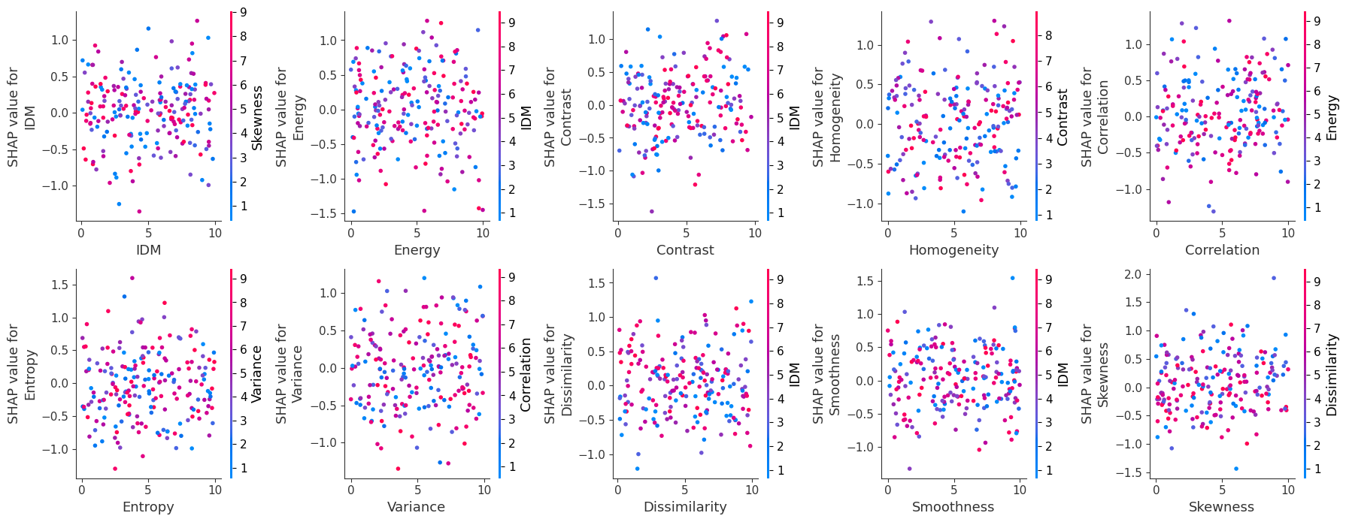

**Figure 8. SHAP Results in Terms of Feature Importance and Individual Scatter Plot**